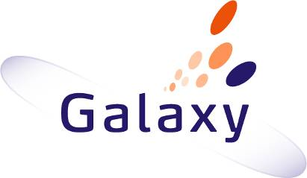

D5.1.5 Communication Framework (FACUS) Use Case Definition
Galaxy use case definition

 | NamE | partner | Date
Written by | A.KAMOUN | LAAS | 25/06/2012
 | S.TAZI
Reviewed by

Record of Revisions
Issue | Date | Effect on |  | Reasons For Revision
 |  | Page | Para
01A | 25/06/2012 |  |  | Document creation

Table of contents
1. Introduction 5
1.1 Goal of this document 5
1.2 Document organization 5
2. SCope 5
2.1 Description of the COMMUNICATION FARMEWORK (FACUS) system 5
2.2 Scope of the study 7
3. Validation method 7
4. Involved PARTNERS 7
5. Validation ScenariOS 7
5.1 Connect to the Galaxy system 7
5.2 Disconnect from the Galaxy system 8
5.3 Join a group in the Galaxy system 8
5.4 Quit a group in the Galaxy system 8
5.5 Add a new role in the Galaxy system 8
5.6 Remove a role in the Galaxy system 9
5.7 Change a role in the Galaxy system 9
6. Involved models 9
7. tools used 9

Table of APPLICABLE DOCUMENTS
N° | title | Reference | Issue | Date | Source
 |  |  |  |  | Siglum | Name

Table of ReferenceD DOCUMENTS
N° | title | Reference | Issue
 | Galaxy glossary | D1.2.2
 | Goal and metrics document | D1.1
 | Architecture specification | D4.1

ACRONYMS AND DEFINITIONS

Except if explicitly stated otherwise the definition of all terms and acronyms provided in [R1] is applicable in this document. If any, additional and/or specific definitions applicable only in this document are listed in the two tables below.
Acronyms
Acronym | DESCRIPTION
Definitions
TERMS | DESCRIPTION

Introduction
The goal of the Galaxy project is to work on the technical hard points related to the fragmentation and to the distributiveness of huge models, and to their synchronization in regards of the communication means classically used by development teams. Galaxy partners believe that a set of technical solution integrated in a common platform of service (called: “the Galaxy platform”) may greatly help in dealing with these hard points.

Based on a selected subset of candidate technologies, the architecture of the platform has been specified. As planned in the project proposal this platform is assessed using use cases where scalability issues can be identified and characterized.

Goal of this document
A specific task of the Galaxy project (T5.1) is dedicated to the definition of the use cases. This document is a product of this task which describes the Communication Framework study case.

Document organization
The chapter 2 describes the context of the test case, including an overview of the domain and a focus on the scope on which of particular interest for the study.

Chapter 3 explains how the approach we have selected to verify and validate the added value of the services provided by the Galaxy platform.

Chapter 4 presents the partners involved on this study case and the way they have contributed to it.

Chapter 5 specifies the scenarios which are used to assess the performance offered by the Galaxy platform.

Chapter 6 describes the models involved in validation scenarios are played: viewpoints, views, sizes and organizations.

Last, Chapter 7 is about the tools software tools used for the validation scenarios.

SCope

Description of the COMMUNICATION FARMEWORK (FACUS) system
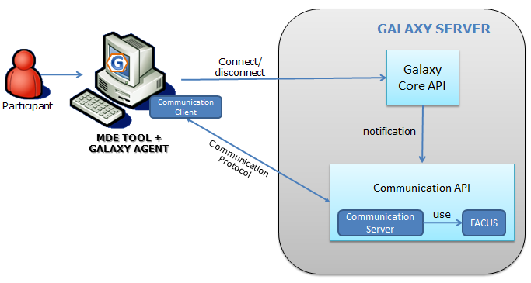

This use case involves the galaxy communication server.
The goal of the communication Framework is to ensure transparent communication between the Galaxy users (such as designers, developers, testers, etc.) who play different roles and belong to one or many groups. Therefore, they are organized dynamically depending on their roles and tasks. In order to achieve this adaptation, a set of interconnected components must be deployed in the system. Since sessions are dynamic and Galaxy users may change their roles during the Galaxy collaborative activities, an adaptive components deployment must be considered to preserve the collaboration.
In order to ensure the collaboration in the Galaxy System 3 phases are required:
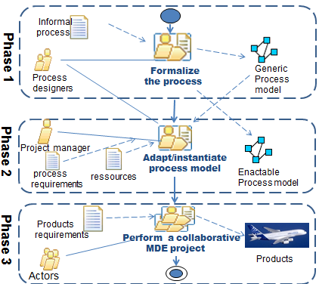

Phase 1:
The process designers begin with defining a process model which contains specific concepts such as groups, roles, activities, relationship, constraints, automatic collaborative sessions for each group, etc. Application-specific rules are also defined and will be used by the adaptation process of the communication Framework in order to determine to what session should belong each actor having a given role or task and belonging to one or many groups. This process model is a specialization of the Generic Collaboration Meta-model implemented within the communication Framework. During this phase, the process designers formalize the process depending on the needed structure. For example, they formalize the collaboration between actors having a common experience, performing common tasks and belonging to one or more projects.
The main advantage here is that the process model (an XML-based file) can be updated at runtime without performing actions on the system’s code implementation. This update may affect sessions’ organization, groups’ definition, possible roles, etc. For example, the process designers can add or remove one or more collaborative session of a given group. Therefore, during the adaptation process, the system’s server has a permanent HTTP access to the defined process model which can be updated.

Phase2:
Once the process model is detected, the Galaxy server instantiates it and allocates to the project all resources. This instance represents the initialization of the application descriptor that will be the entry of the adaptation process. This phase produces an epm (enactable process model) that contains the defined specific concepts and relations defined in the process model such as all potential roles that may be played by actors, all possible groups that may represents sub-projects and mainly the defined collaboration sessions for all groups.

Phase 3:
Once the process model is defined by the process designers and initialized by the Galaxy communication server, actors will be assisted in performing the collaborative project according to the enactable process model, to their roles, to the teams’ organization.
Therefore, the Galaxy communication server should enable the needed adaptation after each actions (such as change involving connection, disconnection , changing roles, joining or leaving a given working group) performed by each actor. Thus, the communication server uses the communication API to notify FACUS about the changes and update the model which has been instantiated in phase 2. In the communication Framework, this model represents the application descriptor which is the entry of each adaptation process.
After each adaptation process, a set of components will be deployed in the actors’ devices to enable the communication within the defined sessions.

Scope of the study
This use case will focus on the communication management contribution in the Galaxy architecture. This contribution to the project doesn’t address directly scalability issues but provides added values on the collaboration process for large projects which involve a large number of contributors (projects managers, quality engineers, designers, developers, testers, etc…)

Validation method
The validation will be carried out by the validation scenarios which will focus of the 1st prototype of Galaxy architecture.

This validation is performed by LAAS-CNRS.
We give different scenarios involving several actions of the Galaxy users (such as connection, disconnection, changing roles and groups, etc.). This enables the validation of the communication API and the communication Framework.

This method allows an early start of the validation activities since the 1st prototype release (mid of June 2012).

Involved PARTNERS
No involved partners.

Validation ScenariOS
In this chapter we will describe the validation scenarios.

Connect to the Galaxy system
This scenario aim to:

- Allow the Galaxy users to connect to the Galaxy system.

The communication server updates the instance of the application model using the communication API and notifies the communication Framework FACUS.
FACUS will be able to run the adaptation process and generate a deployment plan. According to this plan, the needed components will be deployed on the user’s device in order to allow him to collaborate within one or more sessions depending on the chosen role(s) and group(s).

Disconnect from the Galaxy system
This scenario aims to:

- Allow the Galaxy users to disconnect from the Galaxy system.
The communication server updates the instance of the application model using the communication API and notifies the communication Framework FACUS.
FACUS will be able to run the adaptation process and generate a deployment plan. According to this plan, a set of components which are already deployed on the user’s device will be uninstalled in order to disconnect the user from the session(s) in which he was collaborating.

Join a group in the Galaxy system
This scenario aims to:

- Allow the Galaxy users to join a group in the Galaxy system.
The communication server will update the instance of the application model using the communication API and notifies the communication Framework FACUS.
All the roles of the user will be added to the new group.
FACUS will be able to run the adaptation process and generate a deployment plan. According to this plan, the needed components will be deployed on the user’s device in order to allow him to collaborate within the defined sessions of the joined group according to his roles.

Quit a group in the Galaxy system
This scenario aims to:

- Allow the Galaxy users to quit a group in the Galaxy system.
The communication server will update the instance of the application model using the communication API and notifies the communication Framework FACUS.
All the roles of the user will be removed from the group.
Once the model is updated, FACUS will be able to run the adaptation process and generate a deployment plan. According to this plan, a set of components which are already deployed on the user’s device will be uninstalled in order to disconnect the user from all sessions of the group in which he was collaborating.

Add a new role in the Galaxy system
This scenario aim to:

- Allow the Galaxy users to add a new role in the Galaxy system.
The communication server will update the instance of the application model using the communication API and notifies the communication Framework FACUS.
The added role will be added to all groups to which the user belongs.
FACUS will be able to launch the adaptation process and generate a deployment plan. According to this plan, the needed components will be deployed on the user’s device in order to allow him to collaborate within the defined sessions of the joined group according to all his roles and his new added role.

Remove a role in the Galaxy system
This scenario aims to:

- Allow the Galaxy users to remove a given played role in the Galaxy system.
The communication server will updates the instance of the application model using the communication API and notifies the communication Framework FACUS.
The role will be removed from all groups to which the user belongs.
FACUS will be able to run the adaptation process and generate a deployment plan. According to this plan, a set of components which are already deployed on the user’s device will be uninstalled in order to disconnect the user from one or more sessions.

Change a role in the Galaxy system
This scenario aims to:

- Allow the Galaxy users to change a given role in the Galaxy system. The user must choose a new role.
The communication server will updates the instance of the application model using the communication API and notifies the communication Framework FACUS.
The old role will be removed from all groups to which the user belongs. While the new chosen role will be added to all groups to which he belongs.
FACUS will be able to run the adaptation process and generate a deployment plan. According to this plan, a set of components which are already deployed on the user’s device will be uninstalled in order to disconnect the user from one or more sessions thanks to his old role. Other components will be deployed in order to allow the user to collaborate within new sessions according to the new chosen role.

Involved models
List and describe the kind of models (view, viewpoint) involved in the study case and the way they are organized (relationships)

N/A

tools used
List the tools used in this study case with their corresponding version and purpose.

During the validation phase, the following tools will be used:

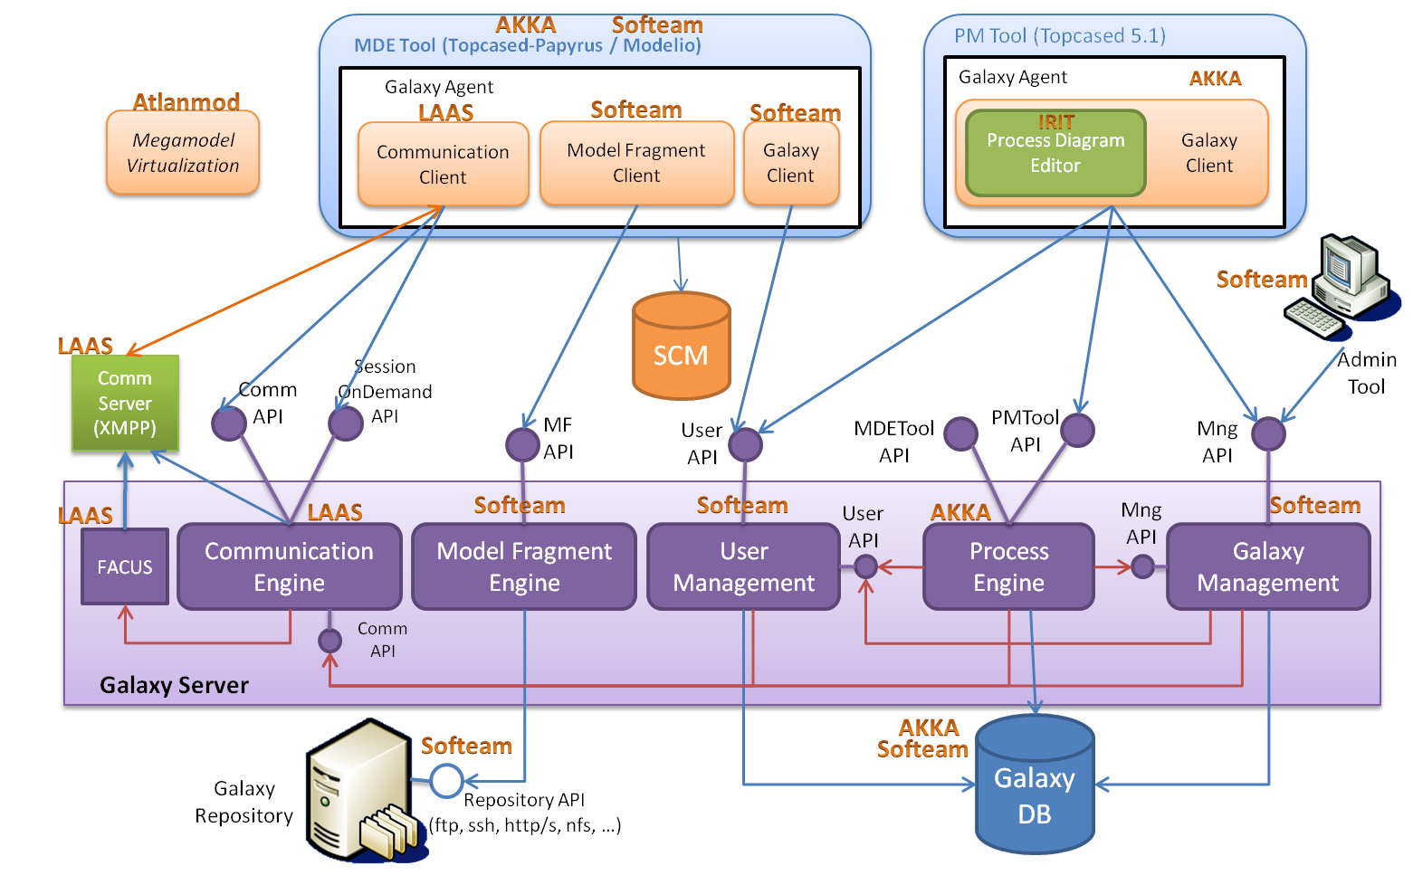

- Galaxy Server
  - FACUS
  - Communication Engine
  - Communication Server
- MDE tool
  - Galaxy Agent
    - Communication client

